**Name**: Mohamed Sayed Emam Ahmed

**B.N**: 723

**Topic**: Artificial Intelligence

**GitHub Link**: https://github.com/mohamedsayed1597/ECE001

**GitHub Pages:** https://mohamedsayed1597.github.io/ECE001/

*Definition of Artificial Intelligence:*

Artificial intelligence (AI) sometimes called machine intelligence, is intelligence demonstrated by machines, in contrast to the natural intelligence displayed by humans and animals. Leading AI textbooks define the field as the study of "intelligent agents": any device that perceives its environment and takes actions that maximize its chance of successfully achieving its goals. Colloquially, the term "artificial intelligence" is often used to describe machines (or computers) that mimic "cognitive" functions that humans associate with the human mind, such as "learning" and "problem solving"

*Applications of Artificial Intelligence:*

AI is used in all fields nearly, it used in Data security, Finance, Health care, Social media, Robotics and E-Commerce. One of applications of AI is Self-driving cars in this application Autonomous vehicles use a combination of computer vision, image recognition and deep learning to build automated skill at piloting a vehicle while staying in a given lane and avoiding unexpected obstructions, such as pedestrians. Another one is Robotics, this field of engineering focuses on the design and manufacturing of robots. Robots are often used to perform tasks that are difficult for humans to perform or perform consistently. For example, robots are used in assembly lines for car production or by NASA to move large objects in space. Researchers are also using machine learning to build robots that can interact in social settings.

*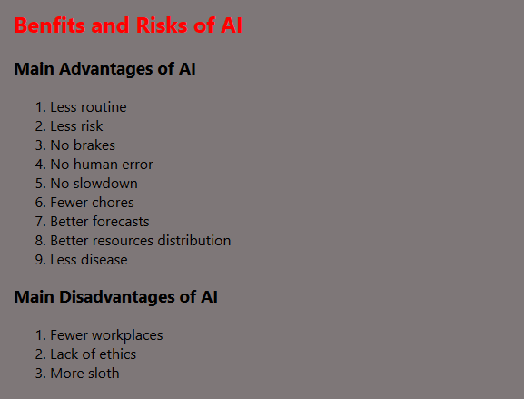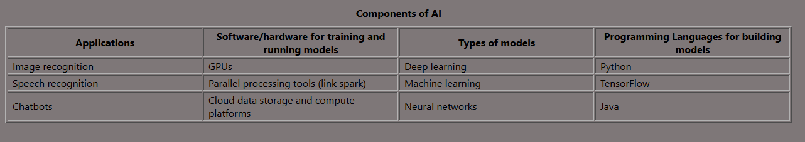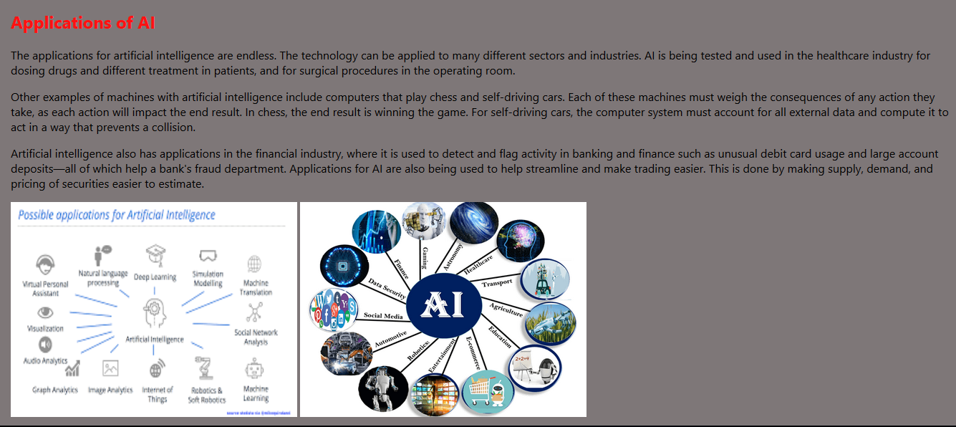Screenshots:*

*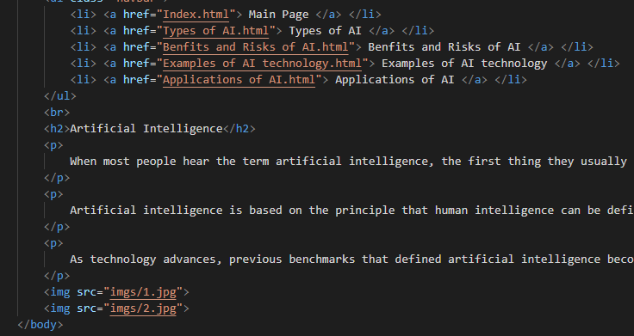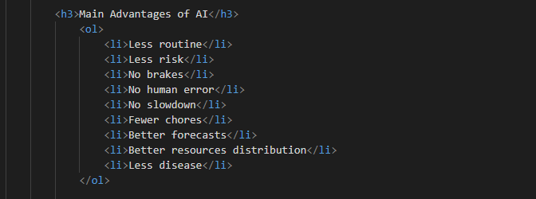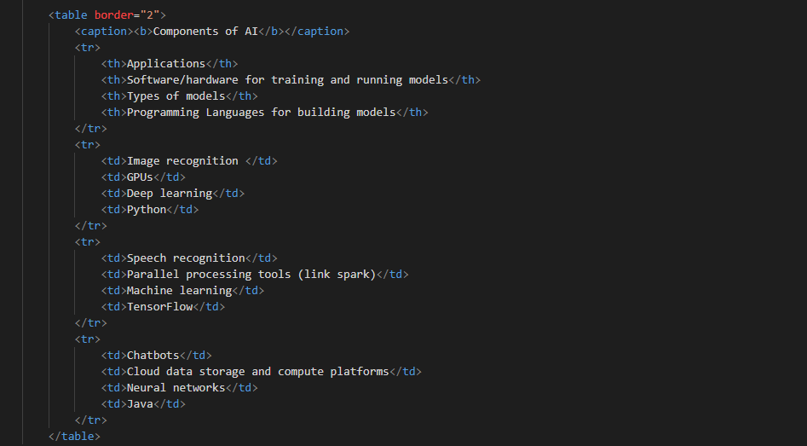Source Code:*